1. Explain me the o2c cycle along with tables(covered in notes)
2. What will happen at interface trip stop (covered in notes)
3. What is autoship(covered in notes)
4. What is the api for shipping

wsh_deliveries_pub. Delivery_Action

1. What are the mandatory parameters for api

api_version_number IN NUMBER,

p_init_msg_list IN VARCHAR2,

x_return_status OUT NOCOPY VARCHAR2,

x_msg_count OUT NOCOPY NUMBER,

x_msg_data OUT NOCOPY VARCHAR2,

1. purpose of Workflow Background Process

Workflow Background Process picks and executes all eligible workflow items related to Oracle Modules like OM,AP,PO,WSH,OKL,ASN,WIP, etc

Workflow Background Process is a concurrent program which is run for processing **deferred** activities, **timed out** activities, and **stuck** processes using the parameters specified

Hence if ItemType parameter is not specified the workflow background process runs will first check for all eligible workflow activities and then run for all eligible workflows this will result in poor performance. It is preferable to execute the Workflow Background Process with specified ItemType.

1. workflow background parameters

**Parameters for “Workflow background process” concurrent program**

 a. Item Type: If you want to restrict workflow engine to a specific Item Type, specify the same here. Else, the engine will process all/any deferred activity regardless of the Item Type.

*b. Minimum Threshold:*If you want to restrict this engine to activities with specific minimum cost, define it here. Otherwise the Workflow engine will process any deferred activity regardless of cost.

*c. Maximum Threshold:*If you want to restrict this engine to activies with specific maximum cost, define it here. Otherwise the workflow engine will process any deferred activities regardless of cost.

*d. Process Deferred:*Specify whether the workflow engine should run deferred. Set it to Yes or No. If this set to yes, the Workflow Background Process will run the workflow activities as a deferred process.

*e. Process Time out:*Specify whether the workflow engine should check for activities that have been timed out. Set it to Yes or No.

1. how to submit workflow back ground process from back end

BEGIN

wf_engine.background (itemtype=>NULL ,

minthreshold=>NULL ,

maxthreshold=>NULL ,

process_deferred=>TRUE ,

process_timeout=>FALSE ,

process_stuck=>FALSE);

END;

1. who will run workflow back ground process in the real time

no one will run,it is an automated program i.e scheduled program.

1. at what point of time sales order line will be closed

After invoice created

1. while creating invoice how many tables affected

ra_customer_Trx_all,ra_customer_Trx_lines_all,ar_payment_schedules_all

12) how many order line level statuses u know in o2c

Shipped,awiting shipping,closed,entered,production open,supply eligible, EXTERNAL_REQ_REQUESTED, EXTERNAL_REQ_open, Awaiting receipt

1. In how many ways we can create sales order

* order import concurrent program
* manual
* oe_order_pub.process_order

parameters are below

Process_Order

( p_org_id IN NUMBER := NULL *--MOAC*

, p_operating_unit IN VARCHAR2 := NULL *-- MOAC*

, p_api_version_number IN NUMBER

, p_init_msg_list IN VARCHAR2 := FND_API.G_FALSE

, p_return_values IN VARCHAR2 := FND_API.G_FALSE

, p_action_commit IN VARCHAR2 := FND_API.G_FALSE

, x_return_status OUT NOCOPY VARCHAR2

, x_msg_count OUT NOCOPY NUMBER

, x_msg_data OUT NOCOPY

1. **order import concurrent program parameters?**

Navigation – order management responsibility

order returns—import orders—order import request

operating unit ,order source,order reference ,validate only

14**) How to display sales rep??**

select jrd.resource_name sales_rep

from oe_order_headers_all ooh,

jtf_rs_salesreps jrs,

jtf_rs_defresources_v jrd

where ooh.SALESREP_ID=jrs.salesrep_id

and jrs.resource_id=jrd.resource_id

and ooh.order_number='69479'

15) how to derive "bill to" ,"ship to" location ?(covered in notes)

Based on tca architecture tables we can build query

*/* Formatted on 2020/10/21 16:18 (Formatter Plus v4.8.8) */*

SELECT h.order_number, h.sold_to_org_id bill_cust_account_id,

h.ship_to_org_id ship_to_site_use_id,

h.invoice_to_org_id bill_to_site_use_id, hp.party_name "Customer Name",

hca.account_name, hca.org_id,

hcasab.orig_system_reference bill_to_orig_ref,

hpb.status bill_to_status,

'ADDRESS1 - '

|| bill_loc.address1

|| ','

|| CHR (10)

|| 'ADDRESS2 - '

|| bill_loc.address2

|| ','

|| CHR (10)

|| 'ADDRESS3 - '

|| bill_loc.address3

|| ','

|| CHR (10)

|| 'CITY - '

|| bill_loc.city

|| ','

|| CHR (10)

|| 'POSTAL CD- '

|| bill_loc.postal_code

|| ','

|| CHR (10)

|| 'COUNTRY - '

|| bill_loc.country bill_to_address,

hcasas.orig_system_reference ship_to_orig_ref,

hps.status ship_to_status,

'ADDRESS1 - '

|| ship_loc.address1

|| ','

|| CHR (10)

|| 'ADDRESS2 - '

|| ship_loc.address2

|| ','

|| CHR (10)

|| 'ADDRESS3 - '

|| ship_loc.address3

|| ','

|| CHR (10)

|| 'CITY - '

|| ship_loc.city

|| ','

|| CHR (10)

|| 'POSTAL CD- '

|| ship_loc.postal_code

|| ','

|| CHR (10)

|| 'COUNTRY - '

|| ship_loc.country ship_to_address

FROM oe_order_headers_all h,

hz_parties hp,

hz_cust_accounts hca,

hz_cust_acct_sites_all hcasab,

hz_cust_acct_sites_all hcasas,

hz_cust_site_uses_all hzsuab,

hz_cust_site_uses_all hzsuas,

hz_party_sites hps,

hz_party_sites hpb,

hz_locations bill_loc,

hz_locations ship_loc

WHERE 1 = 1

AND hp.party_id = hca.party_id

AND hca.cust_account_id = h.sold_to_org_id

AND hcasab.cust_account_id = hca.cust_account_id

AND hcasas.cust_account_id = hca.cust_account_id

AND hpb.location_id = bill_loc.location_id

AND hps.location_id = ship_loc.location_id

AND hcasab.party_site_id = hpb.party_site_id

AND hcasas.party_site_id = hps.party_site_id

AND hcasab.cust_acct_site_id = hzsuab.cust_acct_site_id

AND hcasas.cust_acct_site_id = hzsuas.cust_acct_site_id

AND h.ship_to_org_id = hzsuas.site_use_id

AND h.invoice_to_org_id = hzsuab.site_use_id

AND h.order_number = '&order_number';

16) TCA Architecture

 party-- hz_parties

 account-- hz_cust_accounts

  party site

   party site uses

  account site

  account site uses

  location

TCA – Trading Community Architecture:  
Oracle Trading Community Architecture (TCA) is a data model that allows you to manage complex information about the parties, or customers.  
Trading Community Architecture is the implementation of technology and applications to allow users to create and maintain relationships among entities. It is a way to understand who your customer interacts with inside and outside the enterprise.  
How TCA Matters?  
  
Before TCA:  
  
 There are multiple customer definitions across the enterprise.  
 It was very difficult to track current and historical information about the customers.  
 There was a lack of support for mixed business.  
 It was quite tough to understand relationships between customers and others (suppliers, partners, competitors)  
After TCA:  
  Create a central repository for the entire E-Business Suite to store information relating to all members of a trading community versus separate tables for each member-Prospects, Customers, Contacts, Employees, Partners, Distributors, Suppliers, Banks, etc.  
  Record complex business relationships between Trading Community entities (including 3rd party relationships).  
  Support all business models, industries, and geographies.

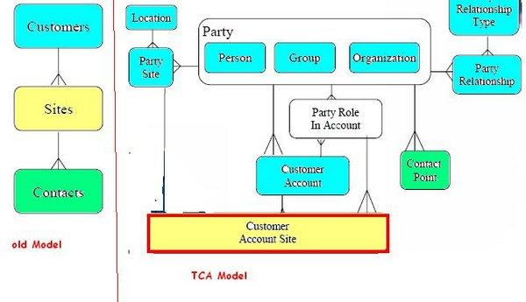

17) sales order holds and its table and releases table

Actions- apply holds

oe_holds.HOLDS_API

oe_hold_definitions

18) how to release holds

Release table

oe_hold_releases

19) what are the programs after pick relase(Covered in notes)

  11) what are the item attributes to enable for item in o2c cycle

Customer ordered,customer orders enabled,shippable,oe transactable.

  12) Back order reasons

* Order on Hold
* Inventory Period NOT open
* No enough on-hand quantity
* No enough quantity to [reserve/transact](http://oracleappsdna.com/2014/12/what-is-the-difference-between-available-to-reserve-available-to-transact/)
* No on-hand quantity in required sub-inventory
* The Lot from which items are selected is inactive/expired
* Wrong Item reservation (even inventory have enough quantity)
* Inventory reserved for other sales orders
* Inventory picked-up by other sales orders
* Previously done return to stock not properly performed
* Move order is in pending state

1. Till what point of time we can cancel sales order line

only order entry,booking

if we try to do at pick release you will get below issue

You are not allowed to cancel Order Line because:

Line has been pick confirmed/staged

15) how to crate invoice automatically

  auto invoice import-- to create invoice automaticaly

15) link between om and ar (covered in notes)

16) link betwen om and ar line level  (covered in notes too)

**AND** ra_customer_Trx_lines_all.interface_line_attribute6 = TO_CHAR (oe_order_lines_all.line_id)

 17) link betwen om and ar header level (covered in notes too )

**AND** ra_customer_Trx_all.interface_line_attribute1 = TO_CHAR (oe_order_headers_all..order_number)

18)  customer outstanding amount /balance amount

ar_payment_schedules_all

due_date,amount_due_original,amount_due_remaining

19) types of sales orders

Ship only ,return only ,regular,standard,web,internal ,mixed

20)Types of  invoices in Account Receivables ?

**Invoice**: A document that you create that lists amounts owed for the purchases of goods or services, any tax, freight charges and payment terms.  
  
**Credit Memo** : A document that partially or fully reverses an original invoice.  
  
**Debit Memo** : Debits that you assign to a customer to collect additional charges .  
  
**ChargeBack** : A new debit item that you assign to your customer when closing an existing, outstanding debit item.  
  
**Deposit**: A type of commitment whereby a customer agrees to deposit or prepay a sum of money for the future purchase of goods and services.  
  
**Guarantee**: A contractual obligation to purchase a specified amount of goods or services over a predefined period of time.

21) How to display open invoices?

select * from ra_customer_trx_all where open_flag='N'

22) Derive credit memo

SELECT rct.trx_number invoice_number, credit.trx_number credi_memo

FROM ra_customer_trx_all rct, ra_customer_trx_all credit

WHERE 1 = 1

AND rct.customer_trx_id = credit.previous_customer_trx_id

AND rct.trx_number = '12086'

24) how to create credit memo

Credit Memo: Negative amount to decrease the balance of the invoice.  
Example of scenario in which a Credit Memo is created:  
Say you have created an invoice of $5000 for a customer ABC and have sent it across. Later upon receiving the goods, customer realized one of them worth $1000 is defective and had to return it. We have already issued an invoice of $5000 but now we are supposed to charge them only $4000 because of the refund of $1000 for the defective piece. In such a situation, we create a credit memo of $1000 and apply to the invoice of $5000 to bring down its balance to $4000. We again send the credit Memo note to the customer to let them know that they have to pay us only $4000.

**To create credit memo ,go to actions- credit memo**

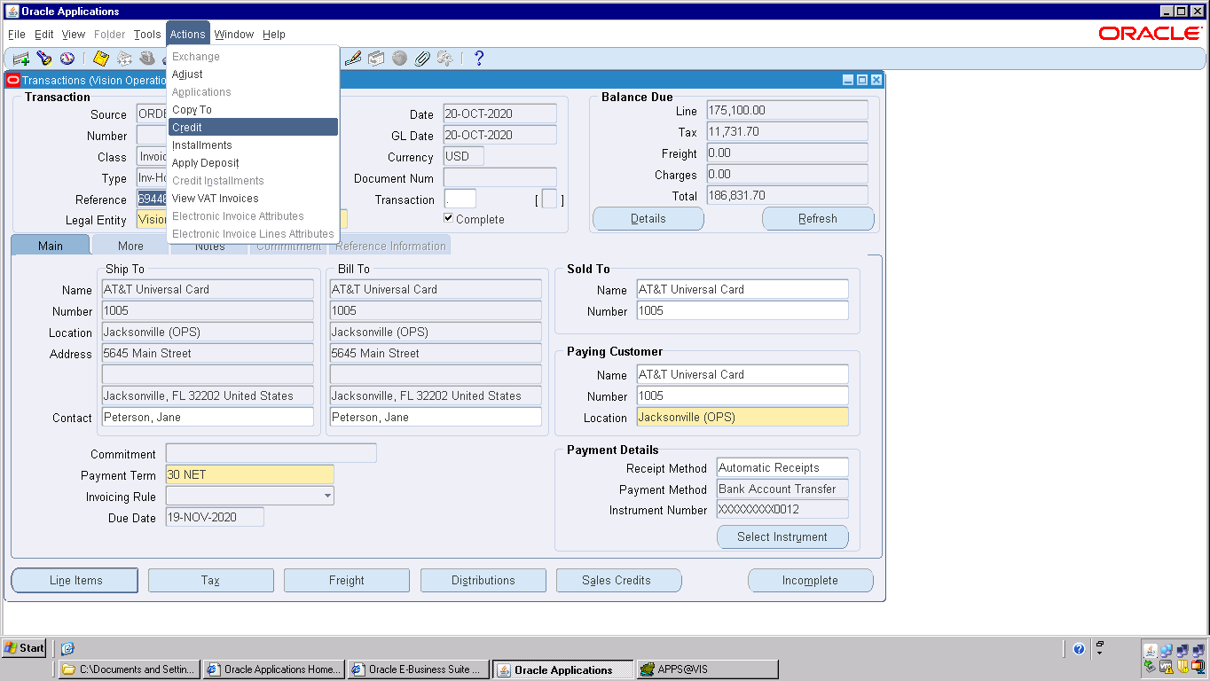

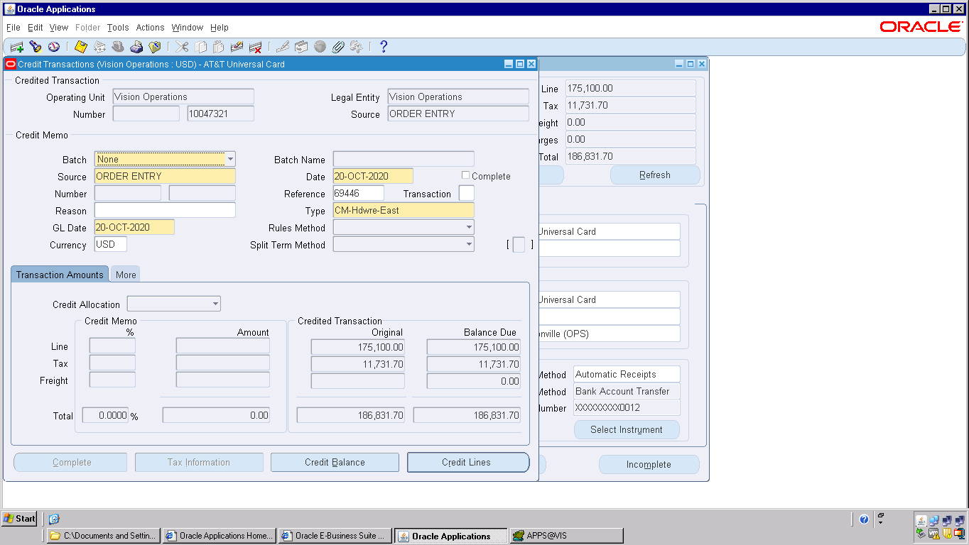

click on credit lines

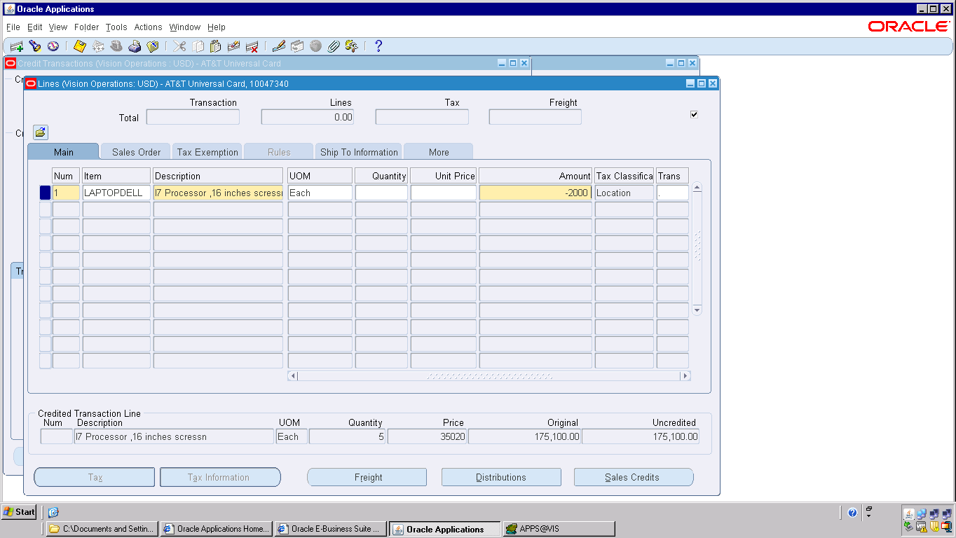

enter negetive amount -2000,it will become <2,000.00>

click on save it will generate credit memo number

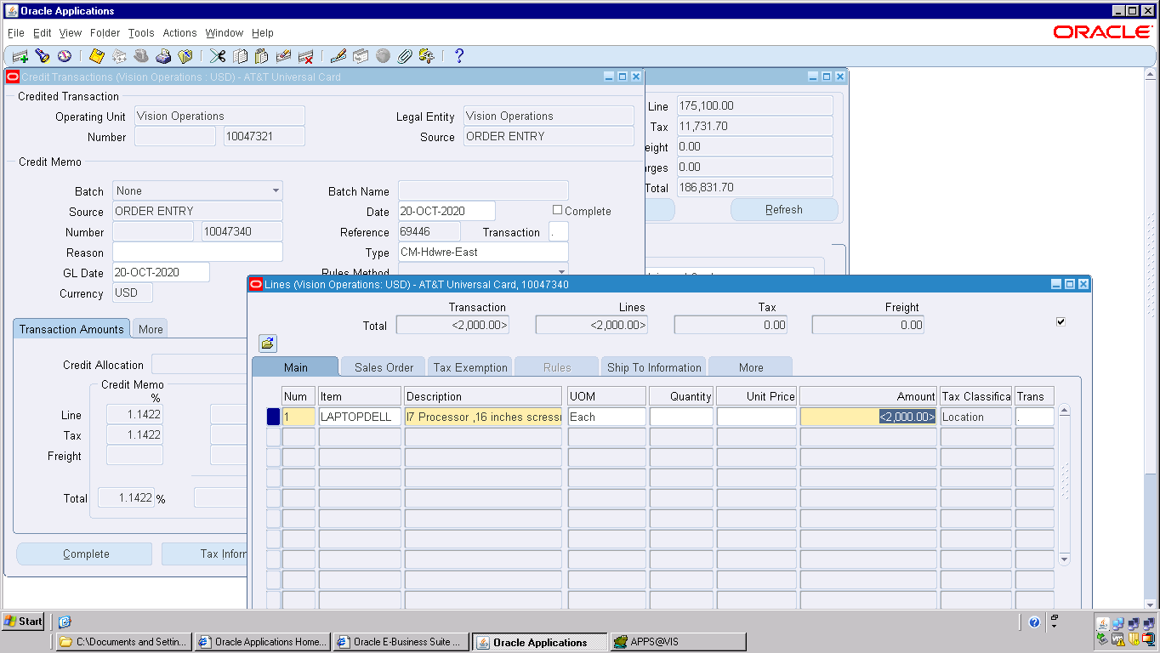

25) AR Receipt Tables

AR_CASH_RECEIPTS_ALL

AR_CASH_RECEIPT_HISTORY_ALL

AR_RECEIVABLE_APPLICATIONS_ALL

26) Auto lock box?

27) sub ledger accounting tables

xla_ae_headers h ,xla_ae_lines l ,xla_events e ,xla_transaction_entities te

xla_distribution_links

28) purpose of xla_distribution_links

28) create accounting modes

1. **Create Draft Accounting:**  
     
   Draft will create journal entries, which are not final, which means they are not ready to be transferred to GL.  
     
   You can see the accounting in xla_ae_headers and xla_ae_lines. But the xla_ae_headers.accounting_entry_status_code is D and also the xla_events.process_status_code is D and event_status_code is U.  
     
   You can run create accounting on this transaction again and again, which will delete the old journal entries and create new ones.  
     
   You can't transfer these journal entries to GL.  
     
   **2.Create Final Accounting:**  
     
   Final will create journal entries, which can be transferred to GL.  
     
   You can see the accounting in xla_ae_headers and xla_ae_lines. But the xla_ae_headers.accounting_entry_status_code is F and also the xla_events.process_status_code is P and event_status_code is P.  
     
   Once it is finally accounted you can't run create accounting on the particular transaction (specifically on that event).  
     
   You can transfer them to GL using Transfer Journal Entries to GL program.  
     
   **3. Create Final Accounting Post To GL:**  
     
   Final Post will create journal entries in final mode, transfer them to GL and post them.  
     
   You can see the accounting in xla_ae_headers and xla_ae_lines. But the xla_ae_headers.accounting_entry_status_code is F and also the xla_events.process_status_code is P and event_status_code is P.  
     
   Once it is finally accounted you can't run create accounting on the particular transaction (specifically on that event).  
     
   It will transfer the journal entries to GL using Journal Import and you can find the data in gl_je_headers and gl_je_lines.  
   Now the xla_ae_headers.transfer_status_code is Y.  
   And also it will post to gl_balances (gl_je_headers.status is P).

29) purpose of journal import - to create journal entries in GL

30 ) GL tables ? (covered in notes)

31) GL period types

General Ledger standard period types Month, Quarter and Year,week

32) Difference between primary ledger and secondary ledger

33) what is chart of accounts?? and its query

Chart of accounts is uses to create the Accounting Flex fields structure in oracle. Chart of Accounts is the combination of many Segments in oracle and we attach the Value sets in these Chart of Accounts segments

SELECT fst.id_flex_structure_name, fseg.segment_num "SEG#",

fseg.segment_name "SEG NAME", vs.flex_value_set_name "VALUE SET",

fseg.flex_value_set_id "VAL_SET_ID"

FROM fnd_id_flex_structures_vl fst,

fnd_id_flex_segments fseg,

fnd_flex_value_sets vs

WHERE fst.id_flex_num = fseg.id_flex_num

AND fseg.flex_value_set_id = vs.flex_value_set_id

AND fst.application_id = 101

AND fst.id_flex_code = 'GL#'

AND fst.id_flex_structure_name LIKE 'Op%Accounting%'

ORDER BY 1, fseg.segment_num

34) KFF (key flex field)  in GL(covered in notes)

35) Journal Types

There are total of five types of journal entries

1) manual journal - Are the journals entered int he system when noother subsystem exists to create the journals. Basically a manual way of going into the general ledger responsibility and creating a journal via data entry.

2) recurring journal - are the journals that occur periodically.

For ex)

- a journal entry that has to be created for rent expense every month

- a journal entry that has to be created for fixed interest expense paid to the bank every month on the bank loan

3) allocation journal - are the journals that allocate or distribute cost pools to various accounts based on usage rations. For example) mass allocation journals for a company's rent expense would allocate rent expense across company's departments based on the square foot usage by that department.

4) budget journal - are journals created in budgets portion of journal ledger. these entries basically insert or update budget data.

5) imported journal - these are the journals that have been imported into the oracle general ledger from oracle receivables or oracle payables etc.

36) GL Budget Types

37) GL Source Types

38) How to know gl period statuses table?

Gl_period_statuses

39) How to display opening balance and closing balance in GL?

SUM(NVL(gb.begin_balance_dr,0)-NVL(gb.begin_balance_cr,0)) Opening_balance,  
SUM(NVL(gb.begin_balance_dr,0)-NVL(gb.begin_balance_cr,0) +  
(NVL(gb.period_net_Dr,0) - NVL(gb.period_net_cr,0))) Closing_bal  
FROM gl_balances gb,  
gl_code_combinations_kfv gcc

40)what is TRIAL Balance

A [*trial balance*](https://www.accountingcoach.com/blog/what-is-a-trial-balance) is a listing of the account names and their balances from the general ledger. The debit balance amounts are in one column and the credit balance amounts are in the adjacent column.

41) cash receipt api name in receivables

AR_RECEIPT_API_PUB

42) shipping api in order management

Wsh_delivery_pub

43) what are defaulitng rules and processing constraints??

Processing constraints are rules that control who can change what and when they can change it. Processing constraints can prevent certain changes, but can also be set up to perform actions based on those changes. They can define actions that can result from these changes, such as requiring a reason for the change, triggering an action in Audit Trail or Versioning, or raising an Integration Event.

This post describes how to set up your processing constraints based on validation conditions in validation templates (for example, Booked = Yes) which are evaluated for groups of records (record sets).

Processing constraints are rules that control

· Who can change?

· What change is allowed?

· When the change is permissible?

Setup processing constraints for Create, Delete, Update and Cancel operations for order or line based on user responsibility.

Example:

Cancel sales orders, order lines, returns, and return lines. Order Management automatically adjusts reservations for canceled lines. The order cancellation feature of Order Management enables you to specify who has the authority to perform a cancellation request. Cancellations look at constraints. If you are allowed to cancel sales, the system will perform a cancellation request. Once a line or order is cancelled, the workflow closes the line.

Processing constraints for orders and returns determine whether you can cancel orders, returns, and lines based on their workflow status. In addition to your user defined processing constraints, system defined rules exist. Under these rules you cannot cancel an order if:

· It has been closed.

· It has already been cancelled

· A work order is open for an ATO line.

· Any part of a line has been shipped or invoiced.

· Any return line has been received or credited.

Order Management honors processing constraints that you define for the Cancel operation that are stricter than these rules, but if you define any that conflict with these rules, they are ignored.

To prevent a responsibility from cancelling:

Navigate to: Setup>Rules>Processing Constraints

44) what are quick codes in order management?

Setup-quick codes- order management

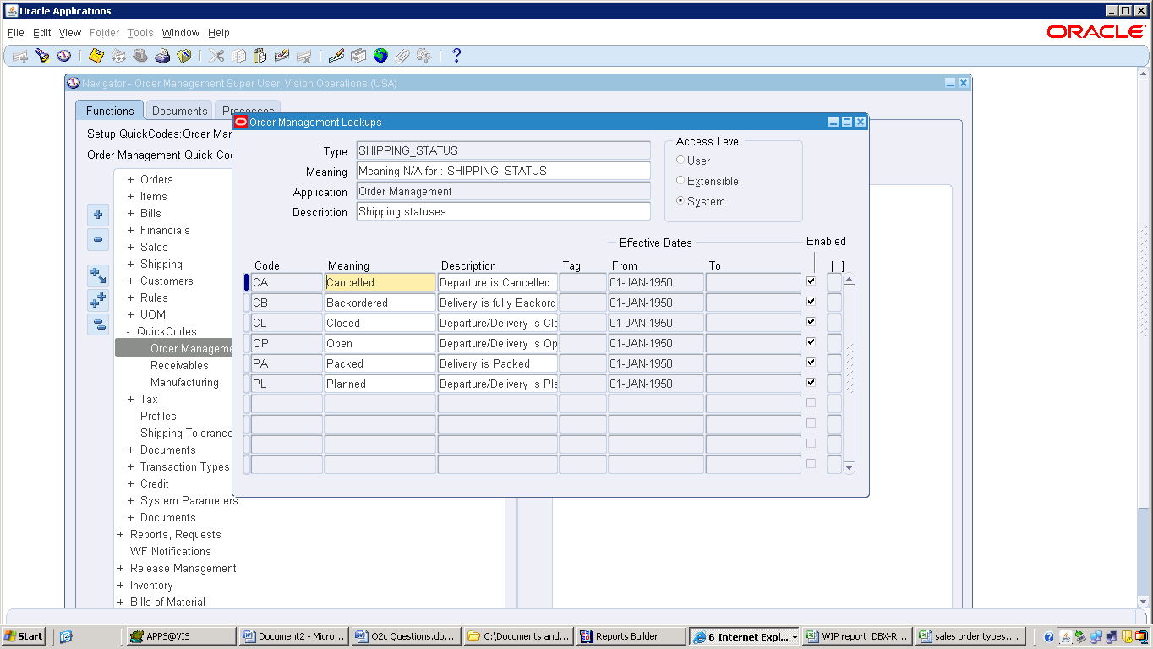

45) ar to sla to gl link query -- covered in notes

SELECT ctt.cust_trx_type_id, lgd.set_of_books_id, lgd.amount gl_posted_amount,

ctl.extended_amount ar_trx_amount, ctl.description inv_item_desc,

gcc.segment1

|| '.'

|| gcc.segment2

|| '.'

|| gcc.segment3

|| '.'

|| gcc.segment4

|| '.'

|| gcc.segment5

|| '.'

|| gcc.segment6

|| '.'

|| gcc.segment7

|| '.'

|| gcc.segment8 gl_account,

gp.period_name, cta.trx_number trx_number,

ctl.interface_line_attribute1 sales_order_number,

ll.line_number sales_order_line_number, ctt.NAME transaction_type,

xdl.unrounded_accounted_cr,

xdl.unrounded_accounted_dr, xdl.unrounded_entered_cr,

xdl.unrounded_entered_dr, xal.gl_sl_link_id,

h.je_category journal_category, h.je_source journal_source,

l.accounted_cr je_lines_accounted_cr,

l.accounted_dr je_lines_accounted_dr,

l.description je_lines_description, l.entered_cr je_lines_entered_cr,

l.entered_dr je_lines_entered_dr, h.NAME journal_name,

b.NAME journal_batch_name, l.je_line_num journal_line_number

FROM ra_cust_trx_line_gl_dist_all lgd,

ra_customer_trx_lines_all ctl,

gl_code_combinations gcc,

gl_periods gp,

oe_order_headers_all h,

oe_order_lines_all ll,

ra_customer_trx_all cta,

ra_cust_trx_types_all ctt, *-- XLA Tables*

xla_distribution_links xdl,

xla_ae_lines xal,

xla_ae_headers xah,

xla_events xle,

xla_transaction_entities xte, *-- GL Tables*

gl_code_combinations_kfv glcc,

gl_import_references gir,

gl_je_headers h,

gl_je_lines l,

gl_je_batches b

WHERE lgd.customer_trx_line_id = ctl.customer_trx_line_id

AND lgd.code_combination_id = gcc.code_combination_id

*-- AND lgd.gl_posted_date BETWEEN '15-DEC-2015' AND '16-DEC-2015'*

AND lgd.org_id = 204

AND gp.period_name = 'Oct-20'

AND lgd.gl_posted_date BETWEEN gp.start_date AND gp.end_date

AND cta.cust_trx_type_id = ctt.cust_trx_type_id

AND cta.customer_trx_id = lgd.customer_trx_id

AND ctl.interface_line_attribute1 = TO_CHAR (h.order_number)

AND ctl.interface_line_attribute6 = TO_CHAR (ll.line_id)

AND xdl.source_distribution_type = 'RA_CUST_TRX_LINE_GL_DIST_ALL'

AND lgd.cust_trx_line_gl_dist_id = xdl.source_distribution_id_num_1

AND lgd.code_combination_id = xal.code_combination_id

AND xal.code_combination_id = glcc.code_combination_id

AND xdl.event_id = xle.event_id

AND xdl.event_id = xah.event_id

AND xdl.ae_header_id = xah.ae_header_id

AND xdl.ae_header_id = xal.ae_header_id

AND xah.entity_id = xte.entity_id(+)

AND xal.gl_sl_link_id = gir.gl_sl_link_id

AND xal.gl_sl_link_table = gir.gl_sl_link_table

AND h.je_batch_id = b.je_batch_id

AND l.je_header_id = h.je_header_id

AND l.je_line_num = gir.je_line_num

AND l.je_header_id = gir.je_header_id

AND cta.trx_number = '10047320'

1. Gl- sla

Gl – gl_import_reference – xla_ae_lines

AND xal.gl_sl_link_id = gir.gl_sl_link_id

AND xal.gl_sl_link_table = gir.gl_sl_link_table

1. Xla to ar

xla_distribution_links

ra_cust_trx_line_gl_dist_all lgd

AND lgd.cust_trx_line_gl_dist_id = xdl.source_distribution_id_num_1

1. Ar to om

Oe_order_headers_all

Oe_order_lines_all

Ra_customer_trx_all

AND ctl.interface_line_attribute1 = TO_CHAR (h.order_number)

AND ctl.interface_line_attribute6 = TO_CHAR (ll.line_id)

46) accounting entries  in o2c

Invoice

---

Receivable – dr

Revenue – cr

Receipts

Receivable – cr

Cash clearance – dr

47) what is move order and its tables in o2c

Mtl_txn_request_headers

Mtl_trx_request_lines

48) how to join sales order table and customer( covered in notes)

49) how to join customer and invoice table ? ( covered in notes)

51) how to use customer as supplier ?

52) gl transalation vs revaluation